Homework 6

Robot Dynamics and Control

Erivelton Gualter dos Santos | 5/2/2019

# Part 1

The objective is to implement and tune an RPBC tracking controller for joints 1,2 and 4 of the WAM robot by simulation, with joint 3 ﬁxed at zero.

Additionally to the RPBC tracking controller, two other controller were evaluated: Inverse Dynamic Based and Passivity-Based Motion control. The following figure illustrates these results.

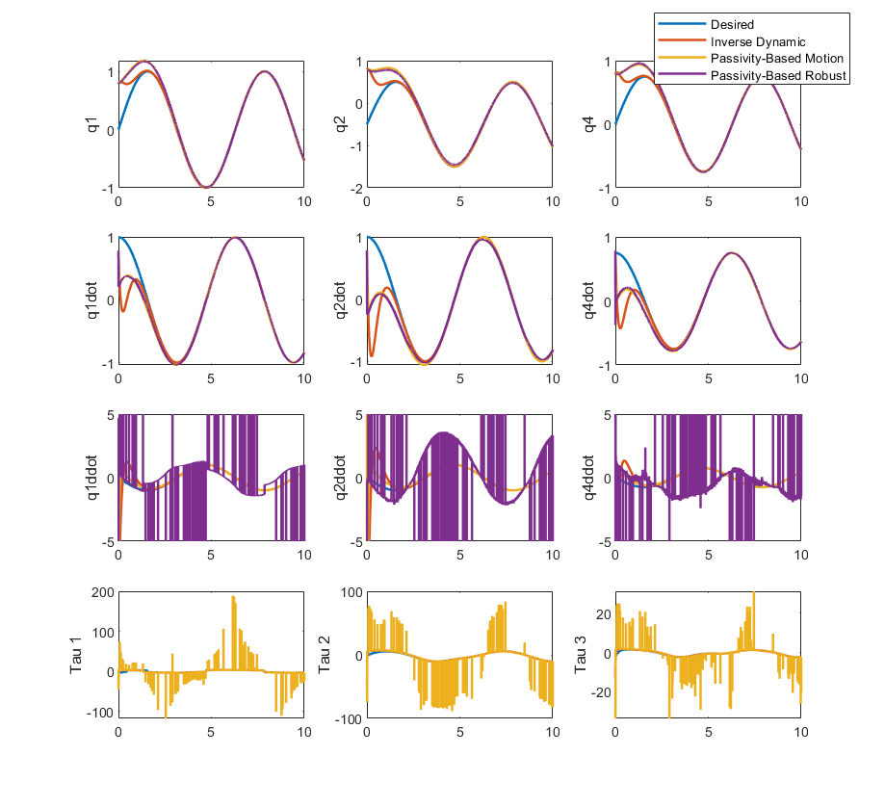

Figure 1 State response for different controllers

In order to evaluate the RPBC tracking, different levels of perturbation were added. Two different of perturbation were implemented. First, consist on add a random o perturbation for each parameter of the robot. Second, consist on a perturbation directly to the TH parameters.

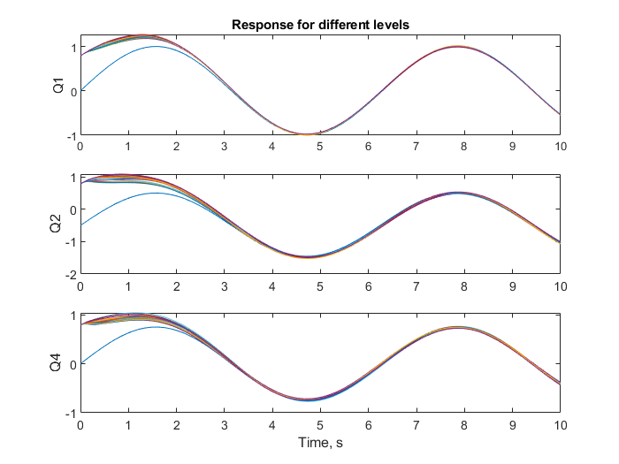

Figure 2 State response for perturbation from 0 to 60%

# Part 2.

Second part correspond to ﬁnd reference trajectories that optimize the numerical conditioning of the regressor for system identiﬁcation.

The following figure correspond to the best results from the optimization. However, the velocity of end point is violated.

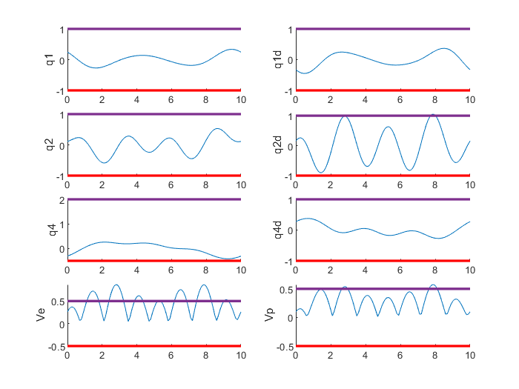

Figure 3 - Position and Velocity Constraints

# Execute Code

Run The following lines of Code

>> MAIN_HW6

>> MAIN_HW6_Optimization